**Project Proposal – (DRAFT)**

**Hristo Hristov**

***Elephant locator***

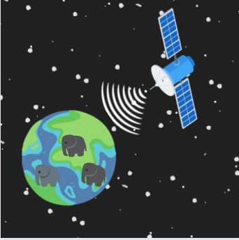

**Teachers:**

Qin Zhao- [q.zhao@fontys.nl](mailto:q.zhao@fontys.nl)

Hans Koning - [h.konings@fontys.nl](mailto:h.konings@fontys.nl)

John Litsenburg - [j.vanlitsenburg@fontys.nl](mailto:j.vanlitsenburg@fontys.nl)

**Fontys University of Applied Sciences**

**Eindhoven – Netherland**

**2021-2022**

Contents

Introduction 3

Domain Understanding 3

1. Who is this A.I. designed for? 3

2. Why make this A.I.? 3

3. How will this project benefit the people using it? 4

4. What are the possible negatives that might come from this A.I.? 4

Data Sourcing 4

1. Where are you able to get data from? 4

2. What difficulties are there in the data provisioning? 5

3. What data cleaning methods (if any) need to be applied? 5

Analytical approach 5

1. Which model will be used? 5

2. Which method will be applied to my model? 5

References 6

# Introduction

The purpose of this document is to present my idea for this semester’s individual challenge. In short, I will be making an A.I. that will take satellite images, scan them, and predict if there are any elephants in the picture. The document will be split into 3 main parts: **Domain Understanding,** **Data Sourcing,** **Analytical Approach.** In these 3 parts I will answer essential questions of Why, What, Who, When & How.

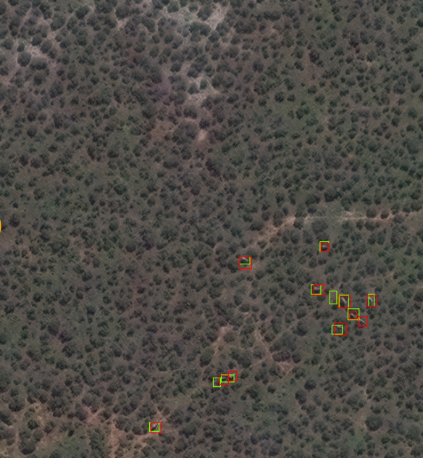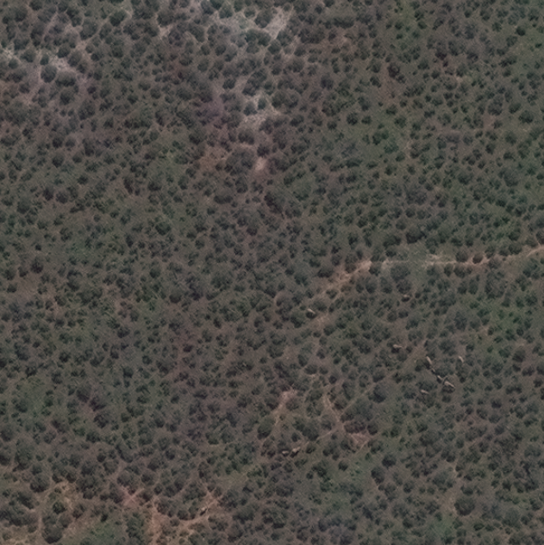

After image recognition is applied Before image recognition is applied

# Domain Understanding

# Who is this A.I. designed for?

* This project is designed towards biologists, wildlife conservationists and all organizations that help in revenging poaching.

# Why make this A.I.?

* African elephants are at risk in the majority of the countries where they live because of poaching. Elephants are killed by locals because of the damage the elephants might cause to their crops, they are also killed for their tusks by people looking to sell them and make money. Human expansion is also a big risk for the elephant population as more and more of their habitat is taken up and used for agriculture or human settlement. This loss of habitat is forcing the elephants to come in contact more and more with humans and is increasing the number of accidents and deaths for both humans and elephants. Humans are trying to prevent elephants from coming into their crop fields and the place where they live by using chili fences/bombs, bee fences and early warning systems to communities. To plan long-term sustainable solutions to the stresses elephants are experiencing, it is necessary to have accurate data on elephant numbers and their geographical range to identify high-risk areas. There are several methods used to conduct elephant surveys, including line transect surveys, dung and track counts, aerial surveys and camera trap surveys but none of these techniques are as effective and we need them to be. This is where this project comes in.
* 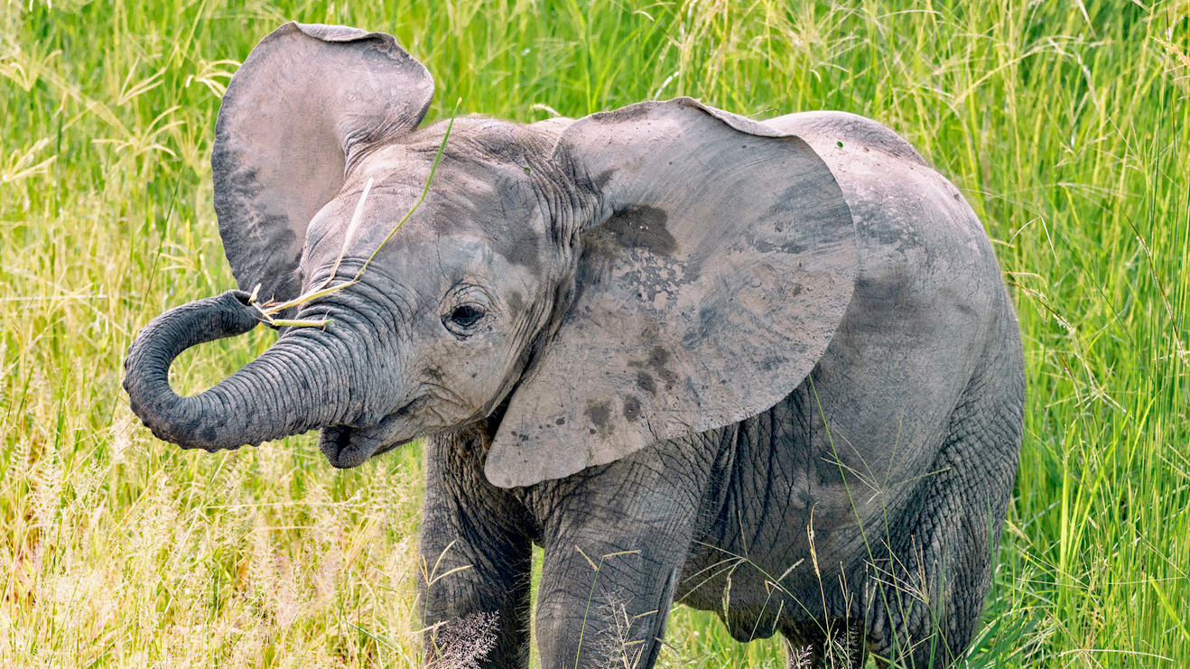

# How will this project benefit the people using it?

* This project will be beneficial by helping track the population of animals in the wild. This can give much more accurate early warnings to people so that unmercenary contact can be avoided. Another application can be the counting of the animal population with the purpose of gaining more data on the numbers of elephants in specific areas.

# What are the possible negatives that might come from this A.I.?

* Since this project will be using satellite images as a resource for tracking, that means that it will be most effective in areas without too much vegetation. In areas where the elephants are not clearly visible for the satellite, accurate tracking will not be possible. Another negative is that if poachers are allowed to use this technology, they can find isolated elephants and kill them more effectively without getting caught.

# Data Sourcing

# Where are you able to get data from?

* I will be sourcing my data from satellite image companies that provide free satellite images, such as: Google Earth, Sentinel Hub, USGS Satellite imagery etc**.**

# What difficulties are there in the data provisioning?

* Since I will be getting all of my data from free sources the image quality that I will have will not be the best possible. This might cause a less accurate A.I. so looking for sources which are both free and can provide me with the quality of data I need will be challenging

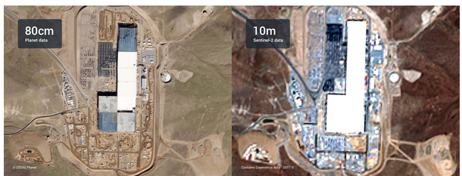

*Example of a paid (commercial image on the left and a free version on the right)*

# What data cleaning methods (if any) need to be applied?

* This project will be focus on image recognition there will need to be a lot of data cleaning done. Since I will be taking as many images as I can get, that will be useful in training my A.I, that would mean taking images from all kinds of different sources and having to standardize them. Possible techniques that I will be using include: Resizing – taking an image resizing it and cropping it into a square. Random Resized Crop - randomly takes part of the image and crops a square from it.

# Analytical approach

# Which model will be used?

* I will be using classification model because I will need to identify objects (elephants) in images.

# Which method will be applied to my model?

* Duo to the nature of my project I will make use of CNN (convolutional neural network) for my image recognition, as from the research I have done on the topic this seems to be the method that yields the best results. Other methods are of course not excluded, and some testing might be done to see the accuracy difference between different algorithms.

# References

Duporge, I., & Isupova, O. (2021, December 1). *Deep learning detects elephants in Maxar satellite imagery on par...* Maxar Blog. Retrieved March 16, 2022, from https://blog.maxar.com/earth-intelligence/2021/deep-learning-detects-elephants-in-maxar-satellite-imagery-on-par-with-human-accuracy

Duporge, I., Isupova, O., & Steven Reece. (2019, December 3). *A new wildlife surveying technique: Using satellite imagery and...* Maxar Blog. Retrieved March 16, 2022, from https://blog.maxar.com/earth-intelligence/2019/a-new-wildlife-surveying-technique-using-satellite-imagery-and-machine-learning-to-detect-and-monitor-elephants?utm_source=blog&utm_medium=organic&utm_campaign=elephant-detection

Coco, A. (2021, March 15). *Data cleaning for Image Classification*. Medium. Retrieved March 16, 2022, from https://aidancoco.medium.com/data-cleaning-for-image-classification-de9439ac1075